**HIGH LEVEL DOCUMENTATION**

**INVESTMENT ANALYSIS**

**Revision Number - 1.1**

**Last Date of Revision - 24/09/2022**

**Arzoo Meshram**

**Document Control**

| **Date** | **Version** | **Description** | **Owner** |
| --- | --- | --- | --- |
| 28th August 2022 | 1.0 | Abstract,  Introduction,  General Description | Arzoo Meshram |
| 18th Sept 2022 | 1.1 | Design Detail, KPI,  Deployment | Arzoo Meshram |
| 24th Sept 2022 | 1.2 | Final Revision | Arzoo Meshram |

**Contents**

Document Version Control…………………………………………………………………………2

Abstract……………………………………………………………………………………………….3

1. Introduction……………………………………………………………………………………….4

1.1 Why this High-Level Design Document?..............................................................4

1.2 Scope……………………………………………………………………………………4

2. General Description……………………………………………………………...5

2.1 Product Perspective & Problem Statement…………………………………………5

2.2 Tools Used……………………………………………………………………………...5

1. Design Detail……………………………………………………………………………………...6

3.1 Functional Architecture………………………………………………………………...6

3.2 Optimization………………………………………………………………………….….7

1. KPI……………………………………………………………………………………………….…8

4.1 KPIs (Key Performance Indicators) ……………………………………………..…...9

1. Deployment……………………………………………………………………………………......9

**Abstract**

The practice of evaluating an investment for profitability and risk is known as Investment Analysis. Its ultimate goal is to determine whether a certain investment is a good fit for a portfolio. It can also range from a single bond in a personal portfolio to a fledgling business investment and even large-scale corporate ventures.

Investment is a game of understanding historic data of investment objects under different events but it is still a game of chances to minimize the risk we apply analytics to find the equilibrium investment.

**1 Introduction**

**1.1 High-Level Design Document**

The purpose of this High-Level Design (HLD) Document is to add the necessary detail to the current project description to represent a suitable model for coding. This document is also intended to help detect contradictions before coding and can be used as a reference manual for how the modules interact at a high level.

**The HLD will:**

* Present all of the design aspects and define them in detail
* Describe the user interface being implemented
* Describe the hardware and software interfaces
* Describe the performance requirements
* Include design features and the architecture of the project
* List and describe the non-functional attributes like:

-Security

-Reliability

-Maintainability

-Portability

-Reusability

-Application compatibility

-Resource utilization

-Serviceability

**1.2 Scope**

The HLD documentation presents the structure of the system, such as the database architecture, application architecture (layers), application flow (Navigation), and technology architecture. The HLD uses non-technical to mildly-technical terms which should be understandable to the administrators of the system.

**2 General Description**

**2.1 Product Perspective & Problem Statement**

The goal of this project is to analyse to predict thefind the equilibrium investment and the practice of evaluating an investment for profitability and risk is known as investment analysis. Its ultimate goal is to determine whether a certain investment is a good fit for a portfolio. It can also range from a single bond in a personal portfolio to a fledgling business investment and even large-scale corporate ventures.

Investment is a game of understanding historic data of investment objects under different events but it is still a game of chances to minimize the risk we apply analytics to find the equilibrium investment.

**2.2 Tools used**

Business Intelligence tools like PowerBi and libraries such as NumPy, Pandas, Matplotlib, MS-Excel,, Jupyter Notebook and Python Programming Language are used to build the whole framework.

* Jupyter Notebook is used as IDE.
* Python is the Programming Language used.
* EDA is done using Numpy & Pandas.
* Visualizations were done using Matplotlib.
* PowerBi is used for dashboard creation.

**3 Design Details**

**3.1 Functional Requirements**

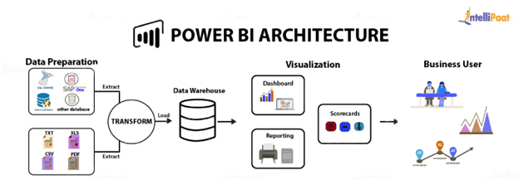

**4 How does PowerBi Work ?**

* Businesses frequently deal with a large volume of data from various resources to execute crucial functions. Power BI is excellent for its data handling ability.
* Power BI can effortlessly and intelligently connect, represent graphically or share data irrespective of being a simple spreadsheet, cloud-based or a hybrid data. It is a web-based platform that is excellent for data analytics and visualization. Hence, it fits or suits any business regardless of its shape and size.
* Here you can constantly monitor vital information and implement various functions through its variety of features.

**The entire working process of Power BI is divided into four steps:**

### **1. Importing Data from Multiple Resources**

* It is the first working step of Power BI, allowing users to import and collect data from multiple sources.
* For example, users can import data from different data sources such as files, databases, folders, emails, websites, cloud-based storage, and other resources.
* After successful data extraction and collection from various sources, these data get compressed to the standard format for storage in the staging area.
* Indeed, the raw data, which is unstructured and unorganized, is stored in the staging area before it gets converted or transformed into a structured format.

### **2. Convert Data Into a Structured Format**

* The second working step of Power BI is to clean the raw data collected from multiple data sources before adding the visual effects.
* The data conversion process continuously checks for missing entry in the table, clean the redundant information, and clean up the duplicate values.
* Afterward, this process makes the data structured, organized, and ready to add visual effects for easy data interpretation.
* Finally, the structured, cleaned, and organized data are loaded and automatically saved in data warehouses to execute business intelligence activities.

### **3. Generate And Publish Interactive Reports**

* In the third working step of Power BI, the users can create interactive and engaging reports using graphs, charts, and custom visual elements.
* In this manner, they can convert the data stored in the data warehouses into engaging and appealing visual reports to understand data better.
* Afterward, the user or an organization can utilize the Power BI development platform to publish the reports using Power BI servers available on-premises or hosted in cloud platforms.
* Organizations or users also publish attractive visual reports in Power BI services for seamless collaboration.

### **4. Create Dynamic Dashboards By Combining Reports**

* The fourth and final step of the Power BI working process consists of generating dynamic dashboards by using the collection of data elements.
* For instance, the users can create interactive dynamic dashboards after publishing the visual reports relevant to the transformed and structured data.
* Finally, an organization’s users can share attractive dashboards with the team members and executives through Power BI services for collaboration and making informed business decisions.
* In this manner, the raw data is transformed into interactive visual dashboards for insights into the data and detailed analysis.

**3.2 Optimization**

1. **Your data strategy drives performance**
   * Minimize the number of fields
   * Minimize the number of records
   * Optimize extracts to speed up future queries by materializing calculations, removing columns and the use of accelerated views
2. **Reduce the marks (data points) in your view**
   * Practice guided analytics. There’s no need to fit everything you plan to show in a single view. Compile related views and connect them with action filters to travel from overview to highly-granular views at the speed of thought.
   * Remove unneeded dimensions from the detail shelf.
   * Explore. Try displaying your data in different types of views.
3. **Limit your filters by number and type**
   * + Reduce the number of filters in use. Excessive filters on a view will create a more complex query, which takes longer to return results. Double-check your filters and remove any that aren’t necessary.
     + Use an include filter. Exclude filters load the entire domain of a dimension while including filters do not. An include filter runs much faster than an exclude filter, especially for dimensions with many members.
     + Use a continuous date filter. Continuous date filters (relative and range-of date filters) can take advantage of the indexing properties in your database and are faster than discrete data filters.
     + Use Boolean or numeric filters. Computers process integers and Booleans (t/f) much faster than strings.
     + Use parameters and action filters. These reduce the query load (and work across data sources).

**Performance**

Investment analytics determines the historicity of all the previous data and it should be as accurate as possible. So that it will not mislead the future investor. Also, model retraining is very important to improve the performance.

**Security**

Since the investment care analysis consists of years of data, the information should be secured.

**Reusability**

The code written and the components used should have the ability to be reused with no problems.

**Resource utilization**

When any task is performed, it will likely use all the processing power available until that function is finished.

**4 KPI**

Dashboards will be implemented to display and indicate certain KPIs and relevant indicators for the Investment.

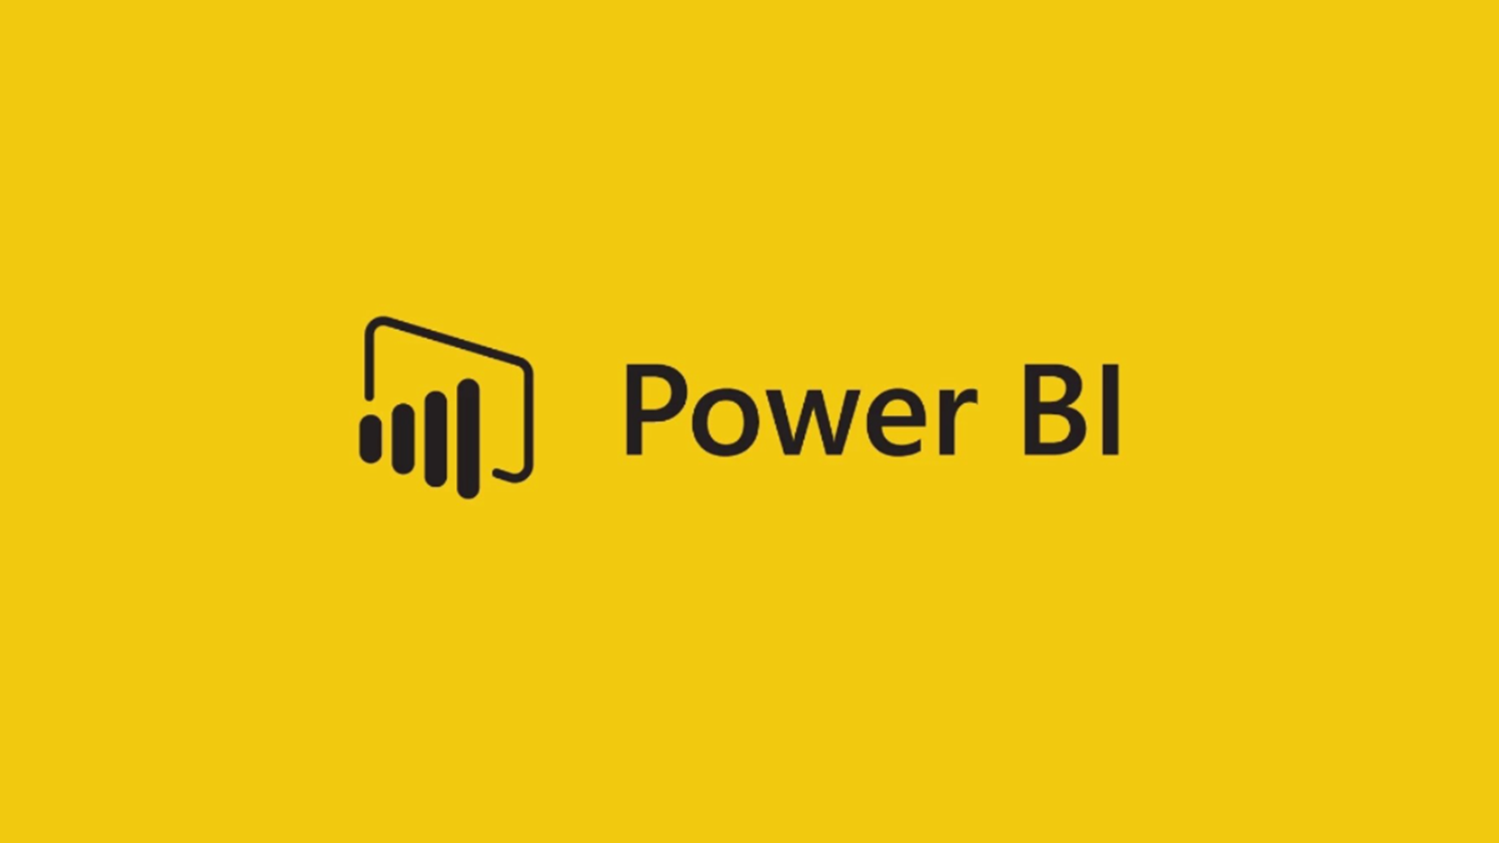

As and when the system starts to capture the historical/periodic data for a Year, the dashboards will be included to display charts over time with progress on various indicators or factors.

**5 Deployment**

PowerBi prioritizes choice in flexibility to fit, rather than dictate, your enterprise architecture. PowerBi leverages your existing technology investments and integrates them into your IT infrastructure to provide a self-service, modern analytics platform for your users. With on-premises, cloud, and hosted options.

The Dashboard is published on PowerBi and an auto-refresh mode has been set so that the dashboard keeps on updating as the real time data loads into the log file.

The Dashboard showcases the multiple insights that has been drawn from the log files as follows:

1. **Sector wise-**This dashboard contains sector wise investment analytics on dataset like total sectors, sectors name and after choosing any sector and see the investment.
2. **Year wise:** This dashboard shows year wise analytics on a given dataset.

